**27 September 2019:**

$$\frac{dy}{dt}=ky\left(t\right), y\left(0\right)=y_{0} y\left(t\right)=ce^{kt}$$

$$\frac{dP}{dt}=kP, P\left(0\right)=P_{0}$$

$$P\left(t\right)=ce^{kt}, P\left(0\right)=c=P_{0}, P\left(t\right)=P_{0}e^{kt}$$

$$P\left(2\right)=P_{0}e^{2k}=3P_{0}, k=\frac{\ln\left(3\right)}{2}≈0.5493$$

$$P\left(t\right)=P_{0}e^{05493t}$$

$P\left(t\right)=2P_{0}, P\left(t\right)=e^{0.5493t}=2P_{0}$

$$0.5493t=\ln{2}→t=\frac{\ln{2}}{0.5493}=1.26h=80min$$

$P\left(10\right)=P_{0} e^{0.5493*10} if P\left(4\right)=P_{0}*e^{0.5493*4}$

$So P_{0}=\frac{5*{10}^{4}}{e^{2.1972}}=5.56*{10}^{3}$

$$So P\left(10\right)=5.568*{10}^{3}*e^{0.5493*10}=1.35*{10}^{6}$$

1. ???? XD

**Example 3:**

$$\frac{dT}{dt}=k\left(T-T_{m}\right)$$

$$→\frac{dT}{T-T_{m}}=kdt$$

$$\int{\frac{dT}{T-T_{m}}}=\int{kdt}$$

$$\ln\left|T-T_{m}\right|=kt+c OR T=T_{m}+ce^{kt}$$

$$We know, T\left(0\right)=300℉$$

$$T\left(0\right)=T_{m}+C=300℉$$

$$C=300-T_{m}$$

$$C=300-70$$

$$T\left(t\right)=70+230e^{kt}$$

$$200=70+230e^{3k}$$

$$k=\frac{\ln{\frac{13}{23}}}{3}=-0.19018$$

$$Alors, T\left(t\right)=70+230e^{-0.19018t}$$

$$If 0℉ then T\left(t\right)=0$$

$$70=70+230e^{-0.19018t}$$

$$\frac{\ln{0}}{-0.19018}=t$$

$$t=∞$$

$$This is mathemathicly correct but not in real lif so Let^{'}s consider that the room temp is 71℉$$

$$71=70+230e^{-0.19018t}$$

$$\frac{\ln{\frac{1}{230}}}{-0.19018}=t$$

$$t=28.59≈30 minutes$$

**EXAMPLE 4:**







$rate of change\frac{dQ}{dt}=rate in-rate out$

$rate in=c*r=0.25r$

$rate out=c*r=\frac{Q\left(t\right)}{100}*r$

$\frac{dQ}{dt}=0.25r-\frac{Q}{100}r; with Q\left(0\right)=Q_{0}$

$\frac{dQ}{dt}=\frac{r}{4}-\frac{r}{100}Q$

$This is a linear and seperable diff equation so we can solve it with either method$

$Q\left(t\right)=ce^{-\frac{r}{100}t}+25$

$Q\left(0\right)=c+25=Q_{0}$

$c=Q_{0}-25$

$Q\left(t\right)=\left(Q_{0}-25\right)e^{-\frac{r}{100}t}+25$

$Long enough time=find \lim_{t→∞}{ }$

$\lim_{t→∞}0.25*100=25$

$\frac{dQ}{dt}=0 | 0.25r-\frac{Q}{100}r=0→Q=0.25*100=25 lb$

$\lim{Q\left(t\right)}=25 lb$

$t→∞$

$2\% of Q_{L}=0.02*25=0.5$

$Q\left(T\right)=50*e^{-0.03T}+25\left(1-e^{-0.03T}\right)=25.5$

$25e^{-0.03T}=0.5$

$T=\frac{\ln{50}}{0.03}≈30 min$

$50e^{-\frac{r}{100}*45}+25\left(1-e^{-\frac{r}{100}*45}\right)=25.5$

$25e^{-\frac{r}{100}*45}≈8.7 gal/min$

**EXAMPLE 5:**

LR-circuits

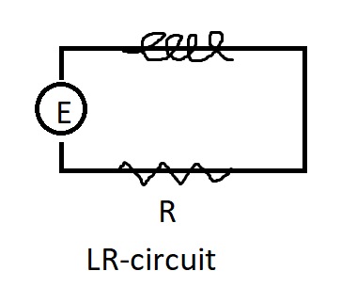

$$L\frac{di}{dt}+Ri=E\left(t\right)$$

$$i\left(t\right)is the current$$

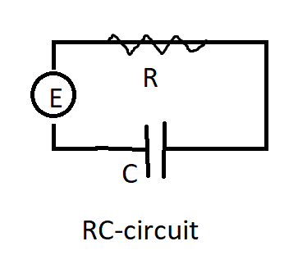

$0.1\frac{di}{dt}+50i=30$

$\frac{di}{dt}+500i=300$

$\frac{d\left(e^{500t}*i\left(t\right)\right)}{dt}=300e^{500t}$

$e^{500t}*i\left(t\right)=300\int{e^{500t}d}=0.6e^{500t}+c$

$i\left(t\right)=ce^{-500t}+0.6$

$\lim_{t→∞}{i\left(t\right)=0.6}$

**EXAMPLE 6: Population Dynamics.**

$$P\left(t\right) \frac{dP}{dt}=kPf\left(p\right)=kP\left(a-bP\right) where a \& b>0$$

$$\frac{dP}{dt}=r\left(1-\frac{P}{k}\right)P r :indenst growth rate (w/o limiting factors)$$

$$K=\frac{r}{a}$$

$$\frac{dP}{dt}=P(a-bP)$$

$\frac{dP}{P\left(a-bP\right)}=dt, \left(\frac{1}{aP}-\frac{b}{a\left(a-bP\right)}\right)dP=dt$

$\frac{1}{a}\ln\left|P\right|-\frac{1}{a}\ln\left|a-bP\right|=t+c$

$\ln\left|\frac{P}{a-bP}\right|=at+ac$

$\frac{P}{a-bP}=ce^{at}$

$P\left(t\right)=\frac{ace^{at}}{1+bce^{at}}=\frac{ac}{bc+e^{-at}}$

$P\left(0\right)=\frac{ac}{bc+1}, c=\frac{P_{0}}{a-bP_{0}}$

$P\left(t\right)=\frac{aP_{0}}{bP_{0}+\left(a-bP_{0}\right)e^{-at}}$

$\frac{dP}{dt}=P(a-bP)$

$\frac{dP}{dt}=0, P\left(a-bP\right)=0, P=0, P=\frac{a}{b}$

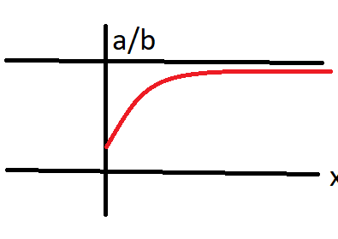

$\lim_{t→∞}{P\left(t\right)=\frac{aP_{0}}{bP_{0}}*\frac{a}{b}}$

$\frac{dP}{P\left({10}^{-1}-{10}^{-7}P\right)}=dt$

$P\left(t\right)=\frac{500}{5*{10}^{-7}+9.95*{10}^{-2}*e^{-0.1t}}$

$\lim_{t→∞}{P\left(t\right)}=\frac{500}{5*{10}^{-4}}={10}^{6}, \frac{a}{b}=\frac{{10}^{-1}}{{10}^{-7}}={10}^{6}$

$P\left(t\right)=\frac{1}{2}P_{L}$

$\frac{500}{5*{10}^{-4}+9.95*{10}^{-2}*e^{-0.1t}}=5*{10}^{5}$

$5*{10}^{-4}+9.95*{10}^{-2}e^{-0.1t}=\frac{500}{5*{10}^{5}}={10}^{-3}$

$0.0995e^{-0.1}=5*{10}^{-4}$

$t=\frac{\ln{0.0199*{10}^{4}}}{0.01}=59.2 m$

**EXAMPLE 7: Chemical Reaction:**

$$A+B→C$$

$$a grams of A is combiened with b grams of B. M parts of A is combiened with N parts of B formed$$

$in C and X\left(t\right) gram of C in C. So, remaining chemicals:$

$A:a-\frac{M}{M+N}X\left(t\right)$

$B:b-\frac{N}{M+N}X(t)$

$\frac{dX}{dt}=k\left(a-\frac{M}{M+N}X\right)\left(b-\frac{N}{M+N}X\right), X\left(0\right)=0$

$a=40g, b=50g, M=2, N=1 (for each B we use, we use 2 A)$

$$\frac{dX}{dt}=k\left(40-\frac{2}{3}X\right)\left(50-\frac{1}{3}X\right)=r\left(120-2X\right)\left(150-X\right), where r=\frac{k}{3}$$

$$\frac{dX}{\left(120-2X\right)\left(150-X\right)}=rdt$$

$$\left(\frac{1}{180\left(60-X\right)}-\frac{1}{180\left(150-X\right)}\right)dX=rdt$$

$$\int{\left(\frac{1}{180\left(60-X\right)}-\frac{1}{180\left(150-X\right)}\right)dX}=\int{rdt}$$

$$\frac{1}{180}\ln\left|\frac{150-X}{60-X}\right|=rt+c$$

$$\frac{150-X}{60-X}=ce^{150rt}, X\left(0\right)=0\frac{150}{60}→c=2.5$$

$$\frac{150-X}{60-X}=2.5*{180}^{rt}$$

$$X\left(5\right)=10, \frac{14}{5}=2.5 e^{180r*5}$$

$$180r=\frac{\ln\left|\frac{28}{25}\right|}{5}=\frac{\ln\left|1.12\right|}{5}=0.223$$

$$\frac{150-X}{60-X}=2.5e^{0.223t}$$

$$X=150\frac{ e^{0.223t}-1}{2.5e^{0.223t}-1}=150\frac{1e^{0.223t}}{2.5-e^{0.223t}}$$